Practical task
Make a glossary of the main notions and give their definitions.
Test
Answer the following questions using one-word/phrase answers:
No | Question | Answer
1 | People engaged in the study of phonetics are called ...
2 | People engaged in the study of phonology are called ...
3 | Variations in pitch, prominence, and tempo are called ...
4 | The basic component of the phonic substance of language is called ...
5 | A unit of spoken message larger than a single sound and smaller than a word is called ...
6 | Pronunciation features in a foreign language influenced by the mother tongue are called ...
7 | How many aspects does the problem of word stress have?
8 | How many components does the phonic substance of language consist of?
9 | The amount of perceptual prominence given to particular words/ syllables in an utterance is called ...
10 | What features are superimposed on the segmental chain of sounds?
11 | Is the statement true or false: English makes use of stressed syllables separated by equal number of unstressed syllables?
12 | Give the name of the founder of phonology.
13 | A sequence of words spoken in a single breath, a stretch of speech which has describable melody is called ...
14 | Knowledge, a code which is known and shared by speakers who use their knowledge for transmitting and interpreting verbal messages in these events is called ...
15 | An activity which is carried on numerous events is called ...
16 | Phonetics whose domain is the larger units of connected speech: syllables, words, phrases and texts is called ...
17 | The part of phonetics which is concerned with individual sounds is called ...
18 | The part of phonetics which is mainly concerned with the functioning of phonetic units in the language is called ...
19 | The science that studies the ways in which pronunciation interacts with society is called ...
20 | The science that investigates a wide range of phenomena from acoustic phonetics to language pathology is called ...

II Practical Task

Practical task
Make a glossary of the main notions and give their definitions.
Test
Answer the following questions using one-word / phrase answers:
No | Question | Answer
1 | Factors lying outside any possibility of signalling linguistic meaning are called ...
2 | Information about stylistic variations in learning, understanding and producing language is studied by ...
3 | The branch of linguistics that is primarily concerned with the problem of functional styles is called ...
4 | A functional set of formal patterns into which language means are arranged in order to transmit information is defined as ...
5 | The science that studies the way phonetic means are used in this or that particular situation, which exercises the conditioning influence of a set of extralinguistic factors, is called ...
6 | Extralinguistic situation can be defined by three components: ...
7 | The cooccurrence of two or more interlocutors related to each other in a particular way, having a particular aim of communicating about a particular topic in a particular setting is defined as ...
8 | What directs the activities of the participants throughout a situation to complete a task?
9 | Individuals taking part in a communicative event are called ...
10 | The component of something associated with the role structure in the family and in social groups, with the assignment of authority and status, and with the attribution of different levels of competence is called ...
11 | Is the following statement true or false: “Gender differences in pronunciation are less numerous than differences in grammatical form”.
12 | The component of situation defined among other features by the physical orientation of participants is called ...
13 | What phonetic factor is the purpose or the aim of the utterance?
14 | The language user’s strategy can be called the speaker’s ...
15 | If the language user considers the situation from his point of view, reveals his personal interest and participation in what he is saying, we speak about ...
16 | The two forms of communication are called ...
17 | Considering a communicative situation from the point of view of sociolinguistics we can speak of the dichotomy ...
18 | When a speaker is listened to by a group of people, speech is qualified as ... and is opposed to ...
19 | The actor’s and the lecturer’s speech as opposed to classroom teaching, television and radio interviews can be characterized as ...
20 | Parts of the utterance that express its main contents are called ...

III. Practical task
- Make a glossary of the main notions and give their definitions.
- Study articulatory features of RP consonants:
RP Consonant Phonemes /Cph: 24
[p] a labial, bilabial, occlusive, plosive, voiceless, fortis consonant phoneme (=Cph)
[b] a labial, bilabial, occlusive, plosive, voiced, lenis Cph
[t] alingual,forelingual,alveolar,occlusive,plosive,voiceless,fortisCph
[d] a lingual, forelingual, alveolar, occlusive, plosive, voiced, lenis Cph
[k] a lingual, backlingual, occlusive, plosive, voiceless, fortis Cph
[g] alingual,backlingual,occlusive,plosive,voiced,lenisCph
[f] a labial, labio-dental, constrictive, fricative, voiceless, fortis Cph
[v] alabial,labio-dental,constrictive,fricative,voiced,lenisCph
[θ] a foreligual, interdental, constrictive, fricative , voiceless, fortis Cph
[ð] a foreligual, interdental, constrictive, fricative , voiced, lenis Cph
[s] aforelingual,alveolar,constrictive,fricative,voiceless,fortisCph
[z] aforelingual,alveolar,constrictive,fricative,voiced,lenisCph
[ʃ] a foreligual, palato-alveolar, constrictive, fricative, voiceless, fortis Cph
[Ʒ] a foreligual, palato-alveolar, constrictive, fricative, voiced, lenis Cph
[h] a glottal, constrictive, fricative, voiceless, fortis Cph
[ʧ] a voiceless affricate
[ʤ] a voiced affricate
[m] a bilabial, occlusive, plosive nasal sonant (S)
[n] an alveolar-apical, occlusive, plosive nasal S
[ŋ] a backlingual, velar, occlusive, plosive nasal S
[1] an alveolar-apical, constrictive, fricative, lateral S
[w] a bilabial, constrictive, fricative, medial S
[r] a post-alveolar, constrictive, fricative, medial S
[j] a medio-lingual, palatal, constrictive, fricative S

3. Fill in the following table featuring the articulatory classification of the English RP consonants:
4. Identify the phonetic process in each word or word combination and fill them in into the appropriate section:
Spar owners, a pair of shoes, left arm, stop pushing, it’s, his shirt, It rains in May, He’s coming this year, exactly, history, correct, ‘cause, lots of money, reference, are, kind- ness, Is that your dog?, miserable, favourite, Let me do that for you, Does your mother know?, far away, police, ‘bout, tell them, ask her, quick cure, vanilla ice-cream, find out, suppose, Would you mind moving?, waste of time, we, ‘round, Be on guard, must
Active organ, place of obstruction  Type of obstruction A manner of the production of noise  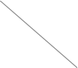 |  | Labial |  | Lingual |  |  |  |  |  | Pharyngal
 |  |  |  | Forelingual |  |  |  | Medio- lingual | Back lingual
 |  | bilabial | labio- dental | inter- dental | alveolar | post- alveolar | palato- alveolar | palatal | velar | glottal
Occlusives | plosives
Occlusives | nasal son- ants
Constrictives | fric- atives
Constrictives | son- ants
Affricates
Connected speech adjustment phenomena |  |  |  |  | Examples
1. Linking r
2. Intrusive r
3. Resyllabification
4. Elongated articulation of the consonant
5. Progressive (perseverative) assimilation
6. Regressive(anticipatory) assimilation
7. Coalescent (reciprocal) assimilation
8. Syncope
9. Aphesis
10. Epenthesis
11. Deletion (elision = ellipsis)
12. Reduction
Test
Answer the following questions using one-word/phrase answers:
No | Question | Answer
1 | How many aspects of speech sounds are distinguished?
2 | How many major types can speech sounds be subdivided into according to the specific character of the work of the speech organs?
3 | [r], [w], [j] are termed ...
4 | Sounds in the production of which the soft palate is lowered, and the air escapes through the nose are called ...
5 | A labial, labio-dental, constrictive, fricative, voiceless, fortis consonant phoneme
45
6 | An alveolar-apical, constrictive, fricative, lateral sonant
7 | A glottal, constrictive, fricative, fortis consonant phoneme
8 | A post-alveolar, constrictive, fricative, medial sonant
9 | A forelingual, palato-alveolar, constrictive, fricative, voiced, lenis consonant phoneme
10 | A lingual, backlingual, velar, occlusive, plosive nasal sonant
11 | A labial, bilabial, constrictive, fricative, medial sonant
12 | A lingual, backlingual, occlusive, plosive, voiceless, fortis consonant phoneme
13 | A lingual, forelingual, post-alveolar, constrictive, fricative, medial sonant
14 | A forelingual, interdental, constrictive, fricative, voiceless, fortis consonant phoneme
15 | A voiceless affricate
16 | How many consonant phonemes re there in RP?
17 | The founder of the phoneme theory is ...
18 | Features of phonemes involved in the differentiation of the words are called ...
19 | Allophones that are free from the influence of the neighbouring sounds and are most representative of the phoneme as a whole are called ...
20 | Allophones which appear as a result of the influence of the neighbouring speech sounds (assimilation, adaptation, accommodation) are called ...
21 | What is the principal function of the phoneme?
22 | The articulatory features which do not serve to distinguish meaning are called ...
23 | The phonemes of a language form a system of ...
24 | The ability to produce English with an English-like pattern of stress and rhythm involves ...
25 | Modifications of a consonant under the influence of a neighbouring consonant are termed ...
26 | A deletion of a sound in rapid or careless speech is termed ...
27 | Connecting of the final sound of one word or syllable to the initial sound of the next one is called ...
28 | Modifications of a consonant under the influence of the adjacent vowel or vice versa are called ...
29 | Inserting of a vowel or consonant segment within an existing string of segments is called ...
30 | The process when two syllables, usually both weak, optionally become one is called ...
31 | According to the degree the assimilating C takes on the characteristics of the neighbouring C, assimilation may be ...
32 | What are the most common types of assimilation in English?
33 | What type of assimilation occurs in the contractions it’s, that’s
34 | What is the name of assimilation in which the first consonant and the second consonant in a cluster fuse and mutually condition the creation of a third consonant with features from both original consonants?
35 | Give an example of affricatization.
36 | Linking and intrusive r are special cases of ...
37 | Define the type of assimilation in ten mice [tem mais]
38 | “Glottalizing” may be used as an allophone of the phoneme ...
39 | Name the phenomenon occurring in the pronunciation of button ['b٨tən] – ['b٨?n]
40 | Name the phenomenon occurring in the pronunciation of camera ['kæmərə] – ['kæmrə]  - Practical task  - Make a glossary of the main notions and give their definitions.  - Study articulatory features of RP vowels.  60  3. Fill in the following table featuring the articulatory features of English RP vowels  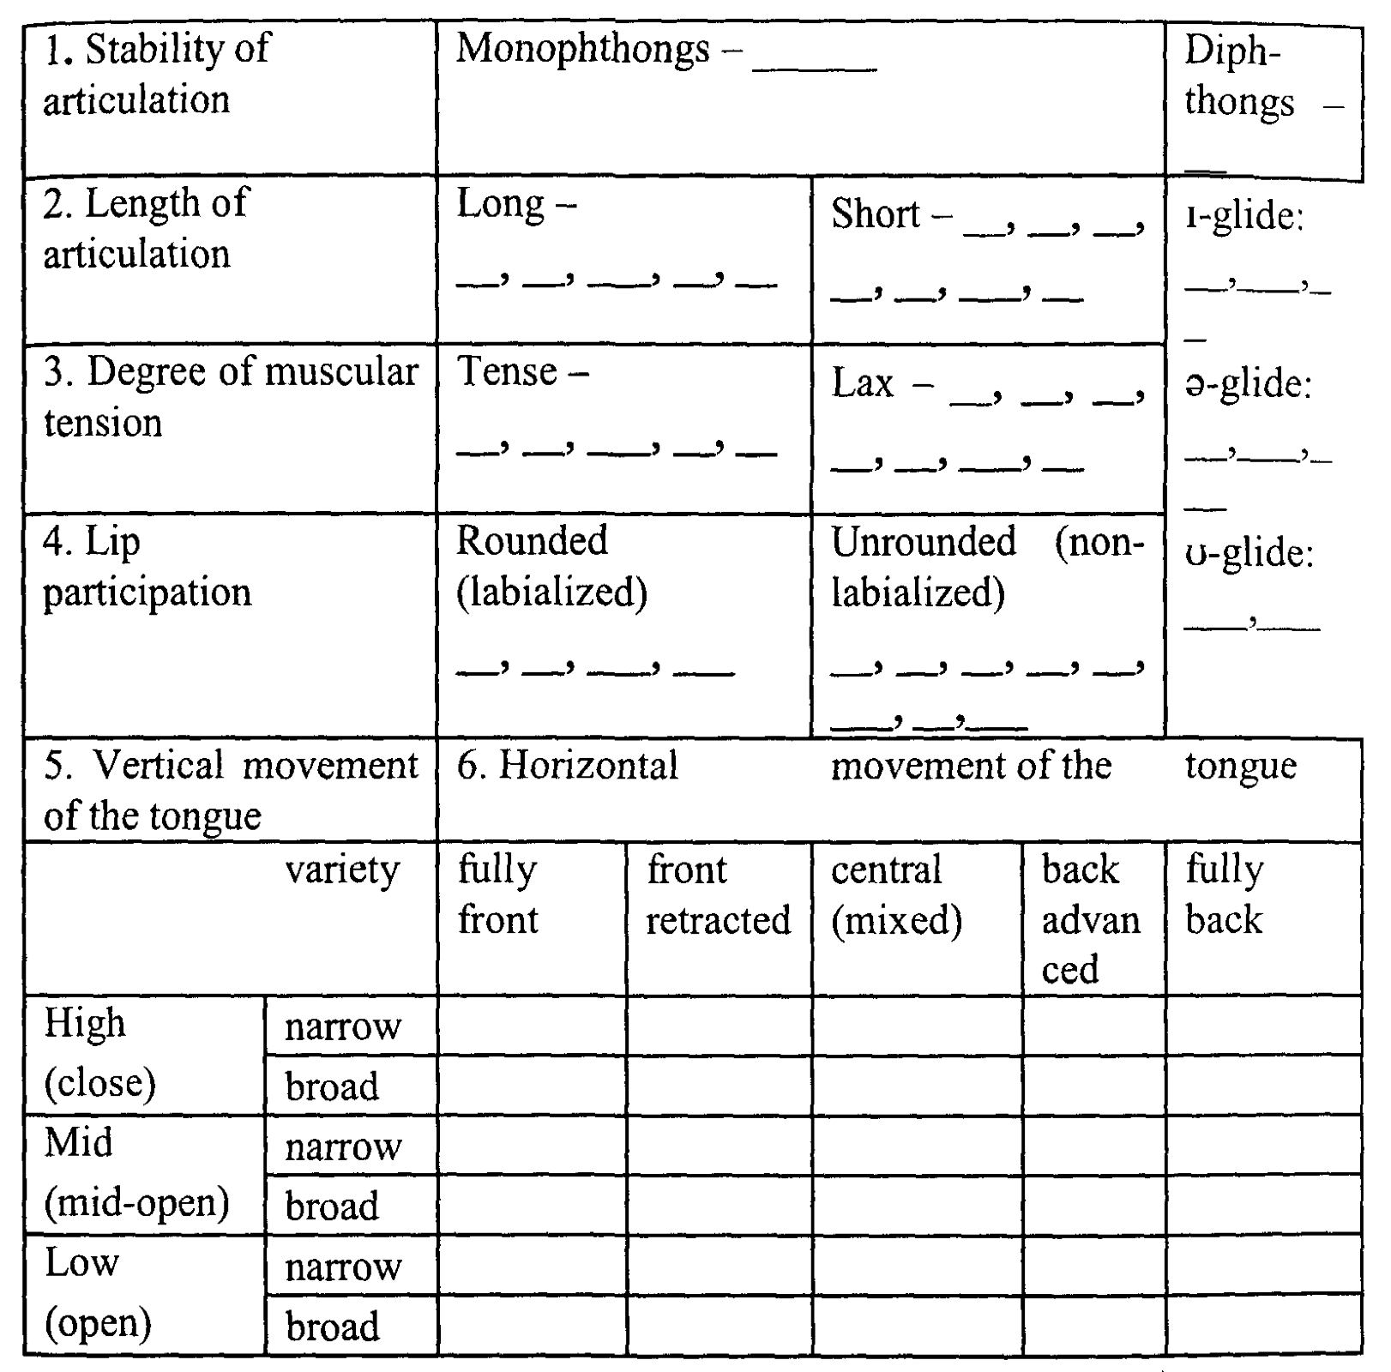  61  Test  Answer the following questions using one-word / phrase answers  - Practical task  1. Make a glossary of the main notions and give their definitions.  2. Divide these words into phonetic syllables. Give their syllabic structural patterns.  3. Mark the stress in the following words: profile, capitalize, unintelligibility, tem- peramental, qualify, situate, dictate, desert (verb), desert (noun), bare-headed.  4. Mark which words contain  81  • A stress-neutral suffix – SN • A stress-imposing suffix – SI • A stressed suffix – S  5. Write each compound in the correct group:  Test
  RP Vowel Phonemes / Vph: 20
  RP Monophthongs / M): 12
  [i:] | a monophthong , long, tense, unrounded, front, high / close vowel phoneme of the narrow variety (=v.)
  [i] | a M, short, lax, unrounded, front retracted, high / close Vph of the wide v.
  [e] | a M, short, lax, unrounded, front, mid / half-open V ph of the narrow v.
  [æ] | a M, half-long, lax, unrounded, front, low / open V ph of the wide v.
  [٨] | a M, short, lax, unrounded, central / mixed, mid V ph of the wide v.
  [a:] | a M, long, tense, unrounded, back, low / open V ph of the wide v.
  [ɒ] | a M, short, lax, rounded, back, low / open V ph. Of the wide v.
  [ɔ:] | a M, long, tense, rounded, back, low / open V ph of the narrow v.
  [u] | a M, short, lax, rounded, back advanced, low / open V ph of the wide v.
  [u:] | a M, long, tense, rounded, back, high / close V ph of the narrow v
  [з:] | a M, long, tense, unrounded, central / mixed, mid V ph of the narrow v.
  [з] | a M, short, lax, unrounded, central / mixed, mid V ph of the wide v.
  RP Diphthongs = 8
  [ei] | a closing diphthong (= D) with the i-glide
  [ai] | a closing D with the i-glide
  [ɔi] | a closing D with the i-glide
  [əu/ зu] | a closing D with the u-glide
  [au] | a closing D with the u-glide
  [iə] | a centering D with the 3-glide
  [eə] | a centering D with the 3-glide
  [uə] | a centering D with the a-glide
  No | Question | Answer
  1 | From the acoustic point of view vowels are called the sounds of ...
  2 | Vowels have no ...
  3 | Sounds whose phonetic content is predominantly made up by the sound waves produced by their voicing are called ...
  4 | A monophthong, half-long, lax, unrounded, front, low / open vowel phoneme of the wide variety
  5 | A monophthong, long, tense, unrounded, central / mixed, mid vowel phoneme of the narrow variety
  6 | A monophthong, long, tense, unrounded, back, low / open vowel phoneme of the wide variety
  7 | A monophthong, short, lax, rounded, back advanced, low / open vowel phoneme of the wide variety
  8 | A monophthong, long, tense, unrounded, front, high / close vowel phoneme of the narrow variety
  9 | A monophthong, short, lax, unrounded, central / mixed, mid vowel phoneme of the wide variety
  10 | A monophthong, short, lax, rounded, back, low / open vowel phoneme of the wide variety
  11 | A monophthong, short, lax, unrounded, central / mixed, mid vowel phoneme of the wide variety
  12 | A monophthong, short, lax, unrounded, front, mid / half-open vowel phoneme of the narrow variety
  13 | Change of consonant or vowel quality, loss of consonants or vowels, and even loss of entire syllables in connected speech are called ...
  14 | The process under which a diphthong optionally loses its second element before another vowel, or it is monophthongized, is called ...
  15 | Vowels are subdivided into ...
  16 | The position of the tongue in the mouth cavity is characterized from two aspects: ...
  17 | Traditionally three lip positions are distinguished: ...
  18 | What articulatory feature characterizes the state of the organs of speech at the moment of producing a vowel?
  19 | In what positions does the shortening of a vowel length occur?
  20 | What changes are vowels of full value subjected to in unstressed syllables?
  No | A word in transcription | Its syllabic structural pattern
  0 | bridle ['braid .ǝ1] | CSVC.S
  1 | people
  2 | copious
  3 | luggage
  4 | militant
  5 | participant
  6 | scatter
  7 | scissors
  8 | tired
  9 | disorientation
  10 | incomprehensible
  Base word | Derivative word and its lexical stress | Type of suffix
  0. climate | climatic | SI
  1. Portugal | Portuguese
  2. poison | poisonous
  3. launder | launderette
  4. infirm | infirmary
  5. period | periodical
  6. punctual | punctuality
  7. separate | separatist
  8. punish | punishment
  9. picture | picturesque
  10.proverb | proverbial
  No | WORD | Early stress | Late stress
  1 | Apple blossom
  2 | apple pie
  3 | cheese grater
  4 | cheese sauce
  5 | jamjar
  6 | jam sandwich
  7 | peach brandy
  8 | peach stone
  9 | mineral water
  10 | orange juice
  No | Question | Answer
  1 | The limit for the number of syllables in English is ...
  2 | The universal syllabic structure in the canonical form is ...
  3 | The division of words into syllables is called ...
  4 | Divide into phonetic syllables the word bottle.
  5 | What symbol is used to designate a syllabic consonant?
  6 | What two types of sounds cannot be split during syllabification?
  7 | Divide in writing the word speaking.
  8 | Divide in writing the word teacher.
  9 | How is the third syllable from end designated?
  10 | How is the syllable preceding the stressed syllable designated?
  11 | What sounds are at the peak of the syllable according to the prominence theory?
  12 | How many degrees of word stress are singled out in English?
  13 | What degree of word stress do American phoneticians add to the traditionally recognized degrees in English?
  14 | Indicate word stress placement in the word increase as a) a verb and b) a noun.
  15 | What syllable of four- or more-syllable words is stressed in English?
  16 | How many types of suffixes are identified from the point of view of their influence on word stress placement?
  17 | What kind of suffixes are –ic, -ity, -ian from the point of view of their influence on word stress placement?
  18 | Give two examples of stress-fixing suffixes.
  19 | Which kind of word stress do typically compounds have?
  20 | Give correct lexical stress in an English teacher for a) a teacher who is English b) a teacher of English  Practical task  1. Make a glossary of the main notions and give their definitions.  2. Explain the following functions of intonation as singled out: a) by David Crystal.  b) Peter Roach.  109  3. Match the given utterances with the adequate nuclear tone and attitude.  ___1. It's possible. ___2. It won't hurt. ___3. I phoned them right away (and they agreed to come). ___4. Red, brown, yellow or.... ___5. She was first! ___6. I'm absolutely certain. ___7. This is the end of the news. ___8. You must write it again (and this time get it right). ___9. Will you lend it to me? ___10. It's disgusting!  4. Mark the nuclear tone you think is appropriate in the following responses.  5. Define the sentence focus in every case.  Mary told John all the secrets. (Not just a few secrets) Mary told John all the secrets. (She didn't tell Richard, or Harold or...) Mary told John all the secrets.(She didn't hint, imply them...) Mary told John all the secrets. (It wasn't Angela, or Beatrice or...) Mary told John all the secrets. (She told him not the news, or the story...).  6. Read the following dialogue and mark the accents.  A Have you taken your family to the zoo, yet, John? B No, but my kids have been asking me to. I've heard this city has a pretty big one. A Yes, it doesn't have a lot of animals, but it has quite a variety of animals. I think  your kids would enjoy seeing the pandas. B I'm sure they would. I'd like to see them, too. A Also, the tigers are worth looking at. B Is it okay to feed them? A No, they're not used to being fed. B What bus do you take to get there? A Number 28. But don't you have a car? B We used to have one, but we had to sell it.  110  7. Divide the sentences into rhythmic groups attaching the unstressed syllable to the preceding stressed syllable rather than the following one.  Thank you for the present. Somebody called you when you were out. I would have tried to see his point of view. Perhaps we might go to the movie together for once. I should think it would be better to wait till tomorrow.  Test  - Practical task  1. Make a glossary of the main notions and give their definitions.  Test | a) an English teacher b) an English teacher
    Function | Explanation
    1. Emotional
    2. Grammatical
    3. Information structure
    4. Textual
    5. Psychological
    6. Indexical
    Function | Explanation
    1. Attitudinal
    2. Accentual
    3. Grammatical function
    4. Discourse function
    a. FALL | b. RISE | c. FALL-RISE | d. RISE-FALL
    finality, | general questions, | uncertainty, doubt | surprise, being
    definiteness | listing, "more to | requesting | impressed
     | follow", encouraging
    Verbal context | Response-utterance | Nuclear tone
    It looks nice for a swim. | It's rather cold (doubtful)
    I've lost my ticket. | You're silly then ( stating the obvious)
    You can't have an ice-cream. | Oh, please (pleading)
    What times are the buses? | Seven o'clock, seven thirty, ...(listing)
    She won the competition. | She did ! (impressed)
    How much work have you got to do? | I've got to do the shopping (and more things after that)
    Will you go? | I might. ( uncertain)
    No | Question | Answer
    1 | Which tone can encourage further conversation, be wondering, mildly puzzled, soothing?
    2 | What meaning does the Fall-Rise express in the response? We’ll ↘go there. – You ↘↗shan’t.
    3 | What are the adjoining unstressed syllables called when they precede the stressed syllable?
    4 | What is the core component of intonation?
    5 | Write the syllables which make the head of the tone unit: “I’ll ask what to do”
    6 | How many rhythmic groups are there in “Thank you for the present”?
    7 | How many major components does intonation consist of?
    8 | What tone expresses the speaker’s active searching for information?
    9 | Intonation is a language ...
    10 | Pitch movements, loudness and tempo form ...
    11 | Give synonyms to the term “semantic centre”
    12 | The pre-nuclear part of the intonation pattern is called ...
    13 | What are the types of the pre-nucleus?
    14 | Pitch ranges can be ...
    15 | Pitch levels may be ...
    16 | The rate of the utterance and pausation are called ...
    17 | Pauses may be ...
    18 | D. Crystal distinguishes ... functions of intonation, while P. Roach summarizes them into ... types.
    19 | The given information is called ..., while the new information is termed ...
    20 | Larger units of connected speech are the domain of ...
    No | Question | Answer
    1 | A system of interrelated intonational means which is used in a social sphere and serves a definite aim of communication is called ...
    2 | The choice of an intonational style is determined primarily by ...
    3 | Informational style includes ...
    4 | Types of style, i.e. certain spheres of discourse are called ...
    5 | A coordinated simultaneous speech act of two participants is called ...
    6 | Besides verbal communication any kind of dialogue involves ...
    7 | Do errors in speech bother communicants in dialogues?
    8 | What is the average length of units in the majority of dialogues?
    9 | Is it true that a reporter or a journlist can be completely independent in his political views of his class, party, country and so on?
    10 | What is the central function of a newspaper?
    11 | Is the speech of radio and television announcers similar?
    12 | Highly skilled newsreaders are capable of making the sense clear by the careful control of ...
    13 | Academic style is described as ...
    14 | Where do we use academic style?
    15 | How should a lecturer sound?
    16 | Who sounds louder a scientific talk presenter or an informational style reader?
    17 | What tones are used in academic style?
    18 | What is the other term for oratorial style?
    19 | Artistic, acquired, stage style is ...
    20 | Familiar style is also termed as ...

